“Smart CPU Scheduler with Dynamic Priority Adjustment”
A Project Report Submitted in the partial fulfillment of the requirements for the award of the degree of

BACHELOR OF TECHNOLOGY
In

DEPARTMENT OF COMPUTER SCIENCE ENGINNERING

By

D ANANYA 2520090011

M VIJAYA LAKSHMI 2520090201

P SHASHANTH 2520090211

Under the Esteemed Guidance of

Dr. G. Alekhya
Assistant Professor
Department of Computer Science and Engineering
Team: 14 Section: 13




K L (Deemed to be) University DEPARTMENT OF COMPUTER SCIENCE ENGINEERING
&

DEPARTMENT OF COMPUTER SCIENCE AND INFORMATION TECHNOL

Declaration

The Project Report entitled “Smart CPU Scheduler with Dynamic Priority Adjustment” is a record of Bonafide work of D ANANYA - 2520090011, M VIJAYA LAKSHMI - 2520090201, P SHASHANTH - 2520090211 submitted in
partial fulfillment for the award of B. Tech in Computer Science and Engineering (or) Computer Science and Information Technology to the K L University. The results embodied in this report have not been copied from any other departments/University/Institute.

D ANANYA 2520090011

M VIJAYA LAKSHMI 2520090201

P SHASHANTH 2520090211

K L (Deemed to be) University

DEPARTMENT OF COMPUTER SCIENCE ENGINEERING

CERTIFICATE

This is certify that the mini project based report entitled “Smart CPU Scheduler with Dynamic Priority Adjustment” is a bonafide work done and submitted by D Ananya – 2520090011, M Vijaya Lakshmi – 2520090201, P Shashanth – 2520090211,
in partial fulfillment of the requirements for the award of the degree of BACHELOR OF TECHNOLOGY in Department of Computer Science Engineering, K L (Deemed to be University), during the academic year 2025-2026.

Signature of the Guide

Signature of the Course Coordinator Signature of the HOD

ACKNOWLEDGEMENT
The success in this project would not have been possible but for the timely help and guidance rendered by many people. Our wish to express my sincere thanks to all those who has assisted us in one way or the other for the completion of my project.

Our greatest appreciation to my Course Coordinator Dr. G. Alekhya, and my guide Dr. G. Alekhya, Department of Computer Science which cannot be expressed in words for his/her tremendous support, encouragement and guidance for this project.

We express our gratitude to Dr. P Venkateshwara Roa (CSE), Head of the Department for Computer Science Engineering for providing us with adequate facilities, ways and means by which we are able to complete this project-based Lab.

We thank all the members of teaching and non-teaching staff members, and also who have assisted me directly or indirectly for successful completion of this project. Finally, I sincerely thank my parents, friends and classmates for their kind help and cooperation during my work.

D ANANYA 2520090011

M VIJAYA LAKSHMI 2520090201

P SHASHANTH 2520090211
Abstract

In priority-based CPU scheduling, a low-priority process may wait for a long time, or even starve, when higher-priority processes keep receiving CPU time. This project, Smart CPU Scheduler with Dynamic Priority Adjustment, is a CPU scheduling simulator that demonstrates how priority aging can make scheduling fairer. The system adjusts the priority of each waiting process based on its waiting time, so that long-waiting processes gradually get a better chance to run.

The scheduler uses the policy Effective Priority = max(0, Base Priority − floor(Waiting Time / Aging Interval)), where a smaller number means a higher priority. This is the selected policy of the project, not a universal CPU scheduling formula. The user enters Process ID, Arrival Time, Burst Time and Base Priority, selects preemptive or non-preemptive mode and sets the aging interval. The system shows the CPU execution sequence in a Gantt chart and calculates completion time, turnaround time, waiting time and response time with their averages. Incorrect inputs and duplicate process IDs are validated. The frontend is built with React and CSS, and the backend with Python and FastAPI.

All processes in the system are simulated; no real operating-system process is created or modified. A fixed-priority baseline for comparison is a planned feature, and performance claims will be made only after it is implemented and tested on the same inputs. The project is intended as a clear, visual and educational tool for understanding CPU scheduling, starvation and aging.

Index

S. No. | Chapter | Topics / Subtopics | Page No.
 | Acknowledgement |  | i
 | Abstract |  | ii
1 | Introduction |  | 8–9
 |  | 1.1 Background of the Project
 |  | 1.2 Problem Statement
 |  | 1.3 Scope of the Project
 |  | 1.4 Objectives of the Project
 |  | 1.5 Importance of the Application
 |  | 1.6 Target Users / Audience
2 | OS Concepts and Background Study |  | 10–11
 |  | 2.1 Operating System Concepts Related to the Project
 |  | 2.2 Existing Methods / Algorithms
 |  | 2.3 Proposed Approach
 |  | 2.4 Advantages of the Proposed Approach
3 | System Requirements |  | 12
 |  | 3.1 Hardware Requirements
 |  | 3.2 Software Requirements
 |  | 3.3 Operating System Environment – Ubuntu / WSL
 |  | 3.4 Development Tools and Compilers
4 | Technology and Tools Used |  | 13
 |  | 4.1 C / C++ Programming
 |  | 4.2 GCC Compiler
 |  | 4.3 Linux System Calls
 |  | 4.4 POSIX Threads / Synchronization
 |  | 4.5 Linux Commands and Utilities
 |  | 4.6 Other Tools / Libraries Used
5 | System Architecture and Design |  | 14–16
 |  | 5.1 Overall System Architecture
 |  | 5.2System Workflow
 |  | 5.3 Flowchart / Data Flow
 |  | 5.4 Module Description
 |  | 5.5 Input and Output Design
6 | Implementation |  | 17–19
 |  | 6.1 Module-wise Implementation
 |  | 6.2 Algorithm / Pseudocode
 |  | 6.3 Core C / C++ Implementation
 |  | 6.4 Linux System Calls / APIs Used
 |  | 6.5 Process / Thread Implementation
 |  | 6.6 IPC / Synchronization Implementation
 |  | 6.7 Memory Management Implementation
 |  | 6.8 Optional User Interface Implementation
7 | Execution and Demonstration |  | 20–22
 |  | 7.1 Compilation in Ubuntu
 |  | 7.2 Execution Commands
 |  | 7.3 Sample Inputs and Outputs
 |  | 7.4 Screenshots of Execution
 |  | 7.5 Demonstration of OS Concepts
8 | Conclusion |  | 23–24
 |  | 8.1 Summary of the Project
 |  | 8.2 Objectives Achieved
 |  | 8.3 Results Achieved
 |  | 8.4 Skills and Learning Outcomes
9 | References |  | 25
 |  | 9.1 Books
 |  | 9.2 Research Papers
 |  | 9.3 Linux / GNU Documentation
 |  | 9.4 Online Resources

CHAPTER -1 INTRODUCTION

1.1 Background of the Project
The CPU of a computer can run only one process at a time. When many processes are ready, the operating system must decide which process gets the CPU next. This decision is made by the CPU scheduler, and the rule it follows is called a scheduling algorithm.
In priority-based scheduling, every process has a priority number and the scheduler picks the process with the highest priority. In this project a smaller number means a higher priority. Priority scheduling is simple, but it has a known weakness: if high-priority processes keep arriving, a low-priority process may wait for a very long time. This situation is called starvation.
A well-known remedy described in operating-system textbooks is aging, where the priority of a waiting process is gradually improved. This project builds a simulator that applies aging, shows the resulting CPU schedule in a Gantt chart, and calculates standard performance metrics.

1.2 Problem Statement
In fixed-priority CPU scheduling, a low-priority process may wait for a long time, or may never run, when higher-priority processes continue to receive CPU time. There is a need for a simple, visual tool that shows this problem and demonstrates how dynamically adjusting priorities based on waiting time can improve fairness.

1.3 Scope of the Project
The scope of the project is limited to a simulation. The following are included:
- Entering Process ID, Arrival Time, Burst Time and Base Priority for simulated processes.
- Selecting preemptive or non-preemptive scheduling and configuring the aging interval.
- Calculating effective priority from waiting time using the selected policy.
- Displaying the CPU execution sequence as a Gantt chart.
- Calculating completion, turnaround, waiting and response times, with their averages.
- Validating incorrect inputs and duplicate process IDs.
- Testing with different arrival and priority scenarios using automated test cases.
The following are outside the scope: scheduling real operating-system processes, modifying the kernel or real Windows processes, I/O bursts, multi-core scheduling, and real-time scheduling guarantees. A fixed-priority baseline for comparison is a planned feature and is described separately wherever it is mentioned.

1.4 Objectives of the Project
- Improve fairness in process scheduling.
- Reduce prolonged waiting and starvation risk.
- Dynamically adjust priorities using aging.
- Visualize execution and calculate performance metrics.
- Compare scheduling strategies using identical inputs once the fixed-priority baseline is implemented.

1.5 Importance of the Application
Scheduling is one of the core topics of an operating-systems course, but students often find it hard to see how the scheduler makes its decisions. This application makes each decision visible: the user can change the input, the mode and the aging interval, and immediately see how the Gantt chart and the metrics change. It also gives a clear demonstration of the starvation problem and of one way to reduce it.
The project does not claim to improve the performance of a real operating system. Its value lies in learning, demonstration and experimentation.

1.6 Target Users / Audience
- Engineering students learning CPU scheduling.
- Teachers and lab instructors who need a live demonstration tool.
- Students and researchers who want to experiment with scheduling policies on identical inputs.
- Hackathon and project evaluators who want to understand the idea quickly.

CHAPTER -2 OS CONCEPTS AND BACKGROUND STUDY

2.1 Operating System Concepts Related to the Project
- Process: a program in execution. In this project a process is a simulated record with an ID, arrival time, burst time and priority.
- Ready queue: the set of processes that have arrived and are waiting for the CPU.
- CPU scheduler: the part of the operating system that selects the next process from the ready queue.
- Preemptive and non-preemptive scheduling: in preemptive mode a running process can be interrupted when a better process is ready; in non-preemptive mode it runs until it finishes.
- Context switch: saving the state of one process and loading another. It is not modelled in detail here; the simulation only records which process runs in each time unit.
- Starvation and aging: starvation is indefinite waiting; aging gradually raises the priority of waiting processes to prevent it.
The scheduling criteria used in this project are completion time, turnaround time, waiting time and response time.

2.2 Existing Methods / Algorithms
Algorithm | Basic idea | Limitation
First Come First Served (FCFS) | Run processes in arrival order | Short processes may wait behind a long one
Shortest Job First (SJF) | Run the shortest burst first | Needs burst knowledge; long jobs may starve
Priority Scheduling | Run the highest-priority process first | Low-priority processes may starve
Round Robin | Give each process a fixed time slice in turn | Does not use priorities; many context switches if the slice is small
Multilevel Queue | Separate queues for different process classes | Rigid if processes cannot move between queues
Table 2.1: Common CPU scheduling algorithms (from standard operating-system textbooks)

2.3 Proposed Approach
The project uses priority scheduling with aging. The effective priority of a waiting process is calculated with the following formula:
Effective Priority = max(0, Base Priority − floor(Waiting Time / Aging Interval))
- Base Priority: the priority given when the process is created. A smaller number means a higher priority.
- Waiting Time: the time the process has spent in the ready queue, that is, current time − arrival time − time already executed.
- Aging Interval: the number of time units a process must wait before its priority improves by one level.
At every scheduling decision, the effective priority of each ready process is recalculated and the process with the smallest value is selected. If two processes have the same effective priority, the process that arrived earlier is selected, and then the one with the smaller Process ID. This is the scheduling policy chosen for this project; it is not a universal CPU scheduling formula.

2.4 Advantages of the Proposed Approach
- A process that waits for a long time gradually becomes more important, so starvation risk is reduced.
- The policy is simple to explain, implement and test.
- The aging interval is configurable, so users can study its effect.
- The Gantt chart and metrics make the behaviour visible.
Limitations: aging does not guarantee a better average waiting time for every workload, and results depend on the process set and the aging interval. Any improvement can only be claimed after measured comparison against a fixed-priority baseline.

CHAPTER -3 SYSTEM REQUIREMENTS

3.1 Hardware Requirements
Component | Minimum | Recommended
Processor | Dual-core, 2 GHz | Quad-core or better
RAM | 4 GB | 8 GB
Storage | 2 GB free space | 5 GB free space
Display | 1366 × 768 | 1920 × 1080
Network | Not required for the simulation (local run) | Needed only to install packages
Table 3.1: Hardware requirements (typical values for web development; the simulator itself is lightweight)

3.2 Software Requirements
Software | Purpose
Python 3 | Scheduling logic and backend
FastAPI and Uvicorn | Backend REST API and server
Node.js and npm | Running and building the React frontend
React and CSS | Dashboard and styling
Python testing framework (for example pytest) | Automated test cases
Modern web browser | Viewing the dashboard
Table 3.2: Software requirements

3.3 Operating System Environment – Ubuntu / WSL
The project is written in Python and JavaScript, which run on Windows, Linux and macOS. It can therefore be run on Windows directly, or in Ubuntu using Windows Subsystem for Linux (WSL). The simulator only works on simulated process records stored in memory. It does not create, inspect or modify real operating-system processes on any platform.

3.4 Development Tools and Compilers
- Python interpreter: Python is interpreted, so no separate compiler is required for the backend.
- Node.js and npm: used to install packages and to run or build the React frontend.
- Code editor: any editor such as Visual Studio Code.
- Terminal: Windows Terminal or the Ubuntu/WSL shell for running commands.
- Web browser: for viewing the dashboard and for testing the user interface.

CHAPTER -4 TECHNOLOGY AND TOOLS USED
Note: some topics in this chapter come from the standard OS project template (C/C++, GCC, Linux system calls and POSIX threads). This project is a Python and web-based simulator, so those topics are marked as not used, with a short explanation.

4.1 C / C++ Programming
Not used. The scheduling algorithm is written in Python because it is easy to read, test and connect to a web API. The same algorithm could be rewritten in C or C++ in future without changing its logic.

4.2 GCC Compiler
Not used, because no C or C++ code is compiled in this project.

4.3 Linux System Calls
Not used. A real operating system uses system calls such as fork, exec and wait to create and manage processes. This project does not call them: processes are simulated records, and no real process is created, changed or terminated.

4.4 POSIX Threads / Synchronization
Not used. The scheduling function is a deterministic, single-threaded simulation that advances a simulated clock. Because it keeps no shared state between requests, no locks or semaphores are needed.

4.5 Linux Commands and Utilities
Standard terminal commands are used for setup and execution, in Ubuntu/WSL or the Windows terminal: pip to install Python packages, uvicorn to run the backend, npm to install and start the frontend, and the testing framework command to run the automated tests.

4.6 Other Tools / Libraries Used
Technology | Role in the project
React | Builds the interactive dashboard: process input table, controls and results
CSS | Styling, layout and the dark theme of the dashboard
Python | Implements the priority-aging and scheduling logic
FastAPI | Provides the REST API and validates incoming requests
Gantt chart view | Displays the CPU execution sequence as a timeline
Automated tests | Check scheduling results and input validation on sample inputs
Table 4.1: Technologies used and their roles

CHAPTER -5 SYSTEM ARCHITECTURE AND DESIGN

5.1 Overall System Architecture
The system has a React frontend and a Python FastAPI backend. The user enters data in the frontend; the backend validates it, applies priority aging, runs the scheduler and returns the schedule and metrics; the frontend then draws the Gantt chart and the dashboard.
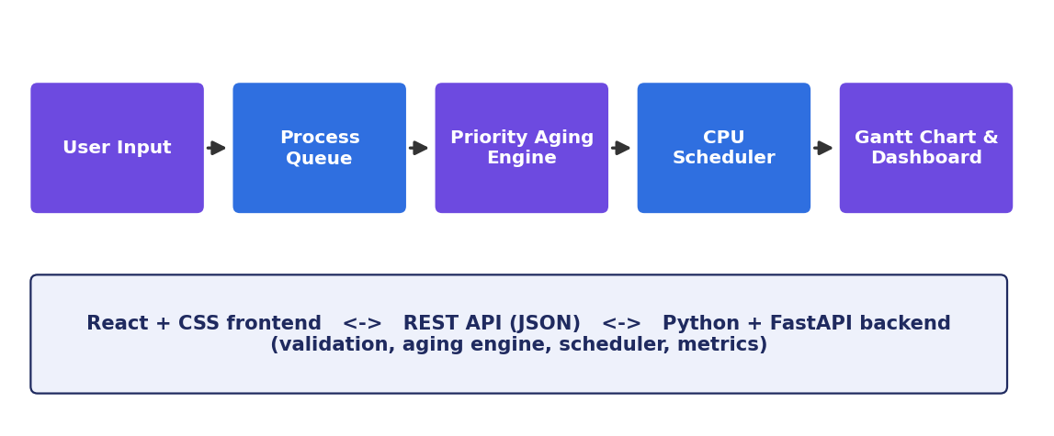
Figure 5.1: System architecture
Component | Purpose
User Input | Collects process data, scheduling mode and aging interval
Process Queue | Holds valid processes and shows which have arrived
Priority Aging Engine | Calculates effective priority from waiting time
CPU Scheduler | Selects the lowest effective-priority process and runs it
Gantt Chart and Dashboard | Shows the execution order and the performance metrics
Table 5.1: Components of the architecture

5.2 System Workflow
- The user enters Process ID, Arrival Time, Burst Time and Base Priority for each process.
- The user selects preemptive or non-preemptive mode and sets the aging interval.
- The backend validates the input (empty list, invalid values, duplicate IDs, invalid aging interval).
- At each decision point, the aging engine calculates the effective priority of every ready process.
- The scheduler selects the process with the smallest effective priority; ties go to the earlier arrival and then the smaller Process ID.
- The process runs to completion (non-preemptive) or for one time unit before the decision is repeated (preemptive).
- When a process finishes, its completion, turnaround, waiting and response times are recorded.
- The Gantt chart, the metrics table and the averages are returned and displayed.

5.3 Flowchart / Data Flow
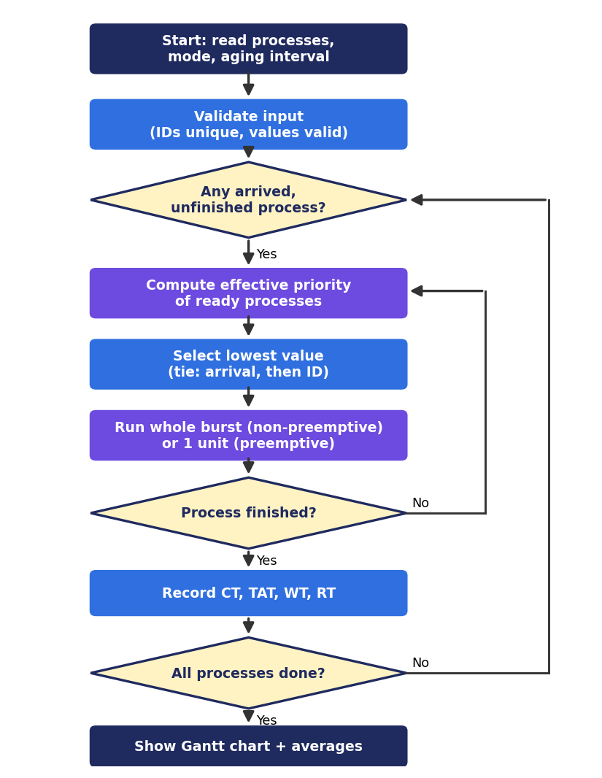
Figure 5.2: Flowchart of the scheduling procedure

5.4 Module Description
Module | Description | Status
Input and Validation | Reads process data and settings; rejects empty input, negative or zero values, duplicate IDs and invalid aging interval | Core feature
Priority Aging Engine | Computes max(0, base − floor(waiting / aging interval)) | Core feature
CPU Scheduler | Selects the next process in preemptive or non-preemptive mode | Core feature
Metrics Calculator | Computes CT, TAT, WT, RT and their averages | Core feature
Gantt Chart and Dashboard | Displays the execution timeline and the results | Core feature
Fixed-Priority Baseline | Runs the same input without aging for comparison | Planned: implement and test before claiming results
Table 5.2: Modules of the system

5.5 Input and Output Design
Input | Rule
Process ID | Required; must be unique
Arrival Time | Integer, 0 or more
Burst Time | Integer, 1 or more
Base Priority | Integer, 0 or more; smaller number = higher priority
Mode | Preemptive or non-preemptive
Aging Interval | Positive integer
Table 5.3: Input design
Output: the Gantt chart (execution sequence with start and end times), a table of completion time, turnaround time, waiting time and response time for each process, the average of each metric, and clear error messages for invalid input.

CHAPTER -6 IMPLEMENTATION
Note: the code and procedures in this chapter describe the reference implementation of the selected policy. The team should replace the listings and names with the final project code and file names where they differ.

6.1 Module-wise Implementation
Module | Implemented by (reference code)
Input and Validation | validate() – checks empty list, duplicate IDs, invalid values, aging interval
Priority Aging Engine | effective_priority() – applies the project formula
CPU Scheduler | schedule() – ready-queue selection, preemptive and non-preemptive execution
Metrics Calculator | Computed inside schedule() from completion and first-start times
API layer | FastAPI endpoint that receives the request and returns the result
Frontend | React components for the input table, controls, Gantt chart and metrics
Table 6.1: Module-wise implementation

6.2 Algorithm / Pseudocode
time = 0
while some process is unfinished:
ready = processes that have arrived and are not finished
if ready is empty:
time = next arrival time # CPU is idle
continue
for each p in ready:
waiting = time - p.arrival - p.executed
p.effective = max(0, p.base - floor(waiting / aging_interval))
chosen = process with smallest effective priority
(tie: earlier arrival, then smaller ID)
run = 1 if preemptive else remaining burst of chosen
run chosen for 'run' time units; time = time + run
if chosen has no remaining burst:
record completion time
compute turnaround, waiting and response time for every process

6.3 Core C / C++ Implementation (written in Python in this project)
The core of the scheduler in Python is shown below. It follows the pseudocode above.
from dataclasses import dataclass

@dataclass
class Process:
pid: str
arrival: int
burst: int
base_priority: int

def validate(processes, aging_interval):
if not processes:
raise ValueError("At least one process is required")
if aging_interval <= 0:
raise ValueError("Aging interval must be a positive integer")
seen = set()
for p in processes:
if p.pid in seen:
raise ValueError(f"Duplicate process ID: {p.pid}")
seen.add(p.pid)
if p.arrival < 0 or p.burst <= 0 or p.base_priority < 0:
raise ValueError(f"Invalid values for process {p.pid}")

def effective_priority(base, waiting, aging_interval):
# Smaller number = higher scheduling priority
return max(0, base - waiting // aging_interval)

def schedule(processes, aging_interval, preemptive=False):
validate(processes, aging_interval)
remaining = {p.pid: p.burst for p in processes}
first_start, completion, gantt = {}, {}, []
time = 0
while len(completion) < len(processes):
ready = [p for p in processes
if p.arrival <= time and p.pid not in completion]
if not ready: # CPU idle until next arrival
nxt = min(p.arrival for p in processes if p.pid not in completion)
gantt.append(["Idle", time, nxt])
time = nxt
continue

def key(p):
waiting = time - p.arrival - (p.burst - remaining[p.pid])
eff = effective_priority(p.base_priority, waiting, aging_interval)
return (eff, p.arrival, p.pid)

chosen = min(ready, key=key)
first_start.setdefault(chosen.pid, time)
run = 1 if preemptive else remaining[chosen.pid]
start, time = time, time + run
remaining[chosen.pid] -= run
if gantt and gantt[-1][0] == chosen.pid and gantt[-1][2] == start:
gantt[-1][2] = time # extend the same Gantt block
else:
gantt.append([chosen.pid, start, time])
if remaining[chosen.pid] == 0:
completion[chosen.pid] = time

rows = []
for p in processes:
ct = completion[p.pid]
tat = ct - p.arrival # Turnaround = CT - Arrival
wt = tat - p.burst # Waiting = TAT - Burst
rt = first_start[p.pid] - p.arrival # Response = First start - Arrival
rows.append((p.pid, ct, tat, wt, rt))
return gantt, rows

6.4 Linux System Calls / APIs Used
No Linux system calls are used. The application programming interface is a REST API between the frontend and the backend. The frontend sends the process list, the mode and the aging interval as JSON; the backend responds with the Gantt data, per-process metrics and averages. FastAPI validates the request fields and returns an error response for invalid data. The exact endpoint names should be taken from the final code.

6.5 Process / Thread Implementation
A process is represented as a simple record with Process ID, arrival time, burst time and base priority. Remaining burst time and first start time are tracked during the simulation. These are simulated processes, not real operating-system processes, and no threads are created by the scheduler.

6.6 IPC / Synchronization Implementation
The only communication between components is the request and response between the React frontend and the FastAPI backend using HTTP and JSON. The scheduler keeps no shared state between requests, so no shared memory, semaphores or locks are required.

6.7 Memory Management Implementation
Memory-management algorithms (paging, segmentation, page replacement) are not part of this project. The process list and the schedule are stored in ordinary in-memory data structures for the duration of one request.

6.8 Optional User Interface Implementation
The dashboard is built with React and CSS. It contains the following parts:
- Process input table for Process ID, Arrival Time, Burst Time and Base Priority.
- Scheduling controls for preemptive or non-preemptive mode and the aging interval.
- A Gantt chart showing the CPU execution sequence.
- A results table and cards for the average waiting, turnaround and response times.
- Error messages for invalid input and duplicate process IDs.
[Insert screenshot of the dashboard here]
Figure 6.1: Dashboard of the Smart CPU Scheduler (to be replaced with a real screenshot)

CHAPTER -7 EXECUTION AND DEMONSTRATION

7.1 Compilation in Ubuntu
Python and JavaScript do not need a separate compilation step. The setup below is for Ubuntu/WSL; the same commands work in a Windows terminal. The file and folder names are typical examples and should be adjusted to the actual project.
# Backend
pip install fastapi uvicorn pytest

# Frontend
npm install

7.2 Execution Commands
# Start the backend (replace "main" with the backend file name)
uvicorn main:app --reload

# Start the frontend
npm start # or: npm run dev, depending on the project setup

# Run the automated tests
pytest

7.3 Sample Inputs and Outputs
The following is an illustrative example, calculated by hand and checked with the reference implementation. Settings: non-preemptive mode, aging interval = 2.
Process | Arrival | Burst | Base Priority
P1 | 0 | 3 | 2
P2 | 1 | 2 | 3
P3 | 2 | 2 | 1
P4 | 3 | 2 | 2
Table 7.1: Sample input
Execution order: P1 (0–3), P3 (3–5), P2 (5–7), P4 (7–9). At time 5, P2 has waited 4 units and its effective priority is 3 − 2 = 1, equal to P4 (2 − 1 = 1). P2 arrived earlier, so it runs first. Without aging, P4 (priority 2) would run before P2 (priority 3).
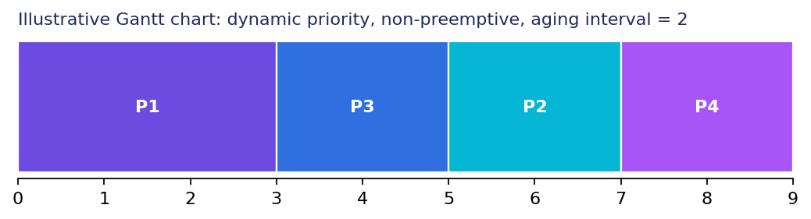
Figure 7.1: Illustrative Gantt chart (dynamic priority, non-preemptive)
Process | CT | TAT | WT | RT
P1 | 3 | 3 | 0 | 0
P2 | 7 | 6 | 4 | 4
P3 | 5 | 3 | 1 | 1
P4 | 9 | 6 | 4 | 4
Average |  | 4.50 | 2.25 | 2.25
Table 7.2: Illustrative metrics (TAT = CT − Arrival; WT = TAT − Burst; RT = First Start − Arrival)
For the same input in preemptive mode the order is P1 (0–2), P3 (2–4), P1 (4–5), P2 (5–7), P4 (7–9), giving average waiting time 2.50, average turnaround time 4.75 and average response time 2.00.
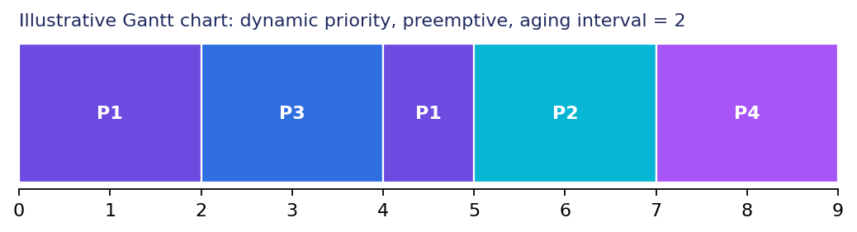
Figure 7.2: Illustrative Gantt chart (dynamic priority, preemptive)
Planned test scenarios. The actual results will be filled in after the tests are run.
Test case | Scenario | Expected result | Actual
Different priorities | P1 priority 3, P2 priority 1, both arrive at 0 | P2 runs first | Pending
Long waiting and aging | Low-priority process waits while others arrive | Its effective priority falls as it waits and it is eventually selected | Pending
Different arrival times | Arrivals at 0, 2 and 5 | Only arrived processes are scheduled; idle gaps are shown | Pending
Equal priorities | Same effective priority | Earlier arrival first, then smaller Process ID | Pending
Empty or invalid input | No rows, negative values, burst 0, duplicate ID, aging interval 0 | Clear error message; no schedule is produced | Pending
Both modes | Same input in both modes | Non-preemptive runs to completion; preemptive can be interrupted | Pending
Table 7.3: Test scenarios and expected results

7.4 Screenshots of Execution
[Insert screenshot: process input table and scheduling controls]
Figure 7.3: Input screen (to be added)
[Insert screenshot: Gantt chart and metrics]
Figure 7.4: Output screen (to be added)
[Insert screenshot: validation error for duplicate Process ID]
Figure 7.5: Input validation (to be added)

7.5 Demonstration of OS Concepts
OS concept | Where it is shown
Ready queue | Processes that have arrived and are waiting are considered at each decision
Priority scheduling | The process with the smallest effective priority is selected
Starvation and aging | Effective priority improves as waiting time grows
Preemptive and non-preemptive scheduling | Mode selection changes the Gantt chart
Scheduling criteria | Completion, turnaround, waiting and response times with averages
Table 7.4: OS concepts demonstrated

CHAPTER -8 CONCLUSION

8.1 Summary of the Project
Fixed-priority scheduling can make low-priority processes wait for a long time. This project presents a CPU scheduling simulator that uses priority aging: the effective priority of a process improves as its waiting time grows. The simulator accepts process details, supports preemptive and non-preemptive modes, lets the user set the aging interval, shows the execution in a Gantt chart and calculates the standard metrics. All processes are simulated; no real operating-system process is touched.
Future scope: add more scheduling algorithms, store process history, analyse different workloads, and carry out a proper performance evaluation against the fixed-priority baseline.

8.2 Objectives Achieved
Objective | Status
Improve fairness using priority aging | Core feature
Reduce prolonged waiting and starvation risk | Core feature
Dynamically adjust priorities using aging | Core feature
Visualize execution and calculate metrics | Core feature
Compare strategies on identical inputs | Planned: baseline to be implemented and tested
Table 8.1: Objectives and status (team to confirm against the final implementation)

8.3 Results Achieved
Measured comparison results are not yet available, so none are claimed. The illustrative example below, calculated by hand for the sample input of Chapter 7 (non-preemptive, aging interval 2), shows how the schedule can change:
Policy | Order | Avg WT | Avg TAT | Avg RT | WT of P2
Dynamic (aging) | P1, P3, P2, P4 | 2.25 | 4.50 | 2.25 | 4
Fixed priority | P1, P3, P4, P2 | 2.25 | 4.50 | 2.25 | 6
Table 8.2: Illustrative hand calculation for one sample input (not a measured result)
In this single example the averages are equal, but the long-waiting process P2 waits 4 units instead of 6. Performance depends on the workload and the scheduling policy, so no general improvement is claimed. The measured comparison table will be completed after the fixed-priority baseline is implemented and tested.
Metric | Dynamic priority | Fixed-priority baseline
Average waiting time | Pending | Pending
Average turnaround time | Pending | Pending
Average response time | Pending | Pending
Maximum waiting time | Pending | Pending
Table 8.3: Measured comparison (to be filled after testing)

8.4 Skills and Learning Outcomes
- Understanding CPU scheduling, priority scheduling, starvation and aging.
- Designing and implementing a scheduling algorithm and calculating scheduling metrics.
- Building a REST API with Python and FastAPI.
- Building an interactive dashboard with React and CSS.
- Writing automated test cases and validating inputs.
- Teamwork, documentation and presenting a technical project.

CHAPTER -9 REFERENCES

9.1 Books
- A. Silberschatz, P. B. Galvin and G. Gagne, Operating System Concepts, Wiley.
- A. S. Tanenbaum and H. Bos, Modern Operating Systems, Pearson.
- W. Stallings, Operating Systems: Internals and Design Principles, Pearson.

9.2 Research Papers
No research papers have been cited so far. [Add any papers referred to by the team.]

9.3 Linux / GNU Documentation
Not applicable. No Linux or GNU-specific documentation was used for this project.

9.4 Online Resources
- FastAPI documentation: https://fastapi.tiangolo.com
- React documentation: https://react.dev
- Python documentation: https://docs.python.org/3/

